**ShoppyGlobe E-Commerce API Project**

**Project Overview**

This project aims to create a backend API for ShoppyGlobe, an e-commerce application, using Node.js, Express.js, and MongoDB.

**Objectives**

* Develop RESTful APIs to manage products and shopping cart functionalities.
* Implement user authentication and authorization.
* Ensure robust error handling and input validation

**1. Get All Products**

* **Endpoint:** GET /api/v1/products
* **Description:** Retrieves all products from the database.
* **Response:** Array of product objects.

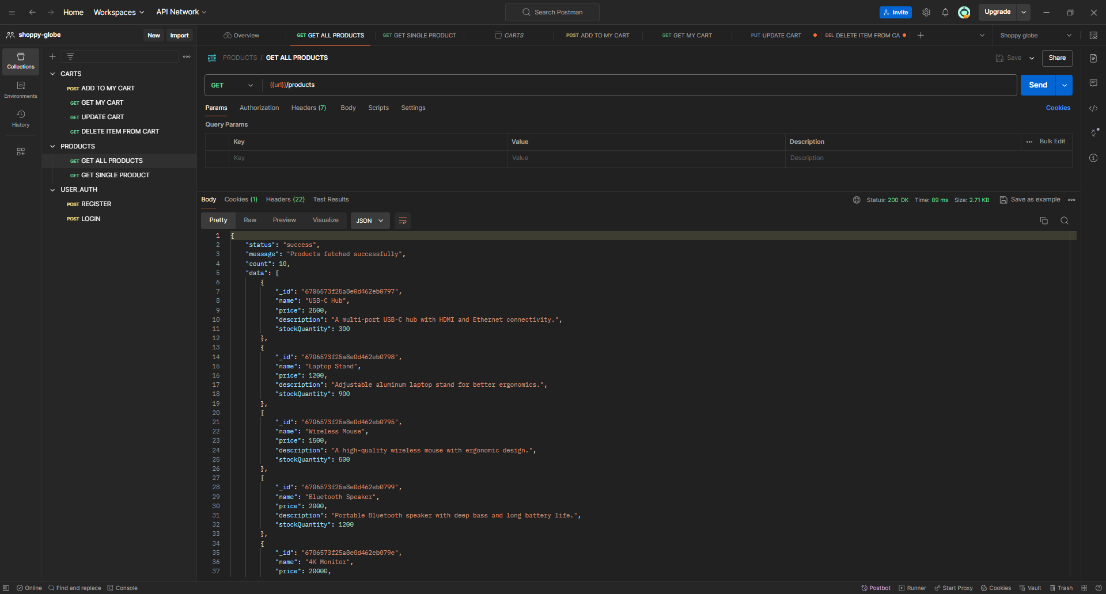

MongoDB SC - 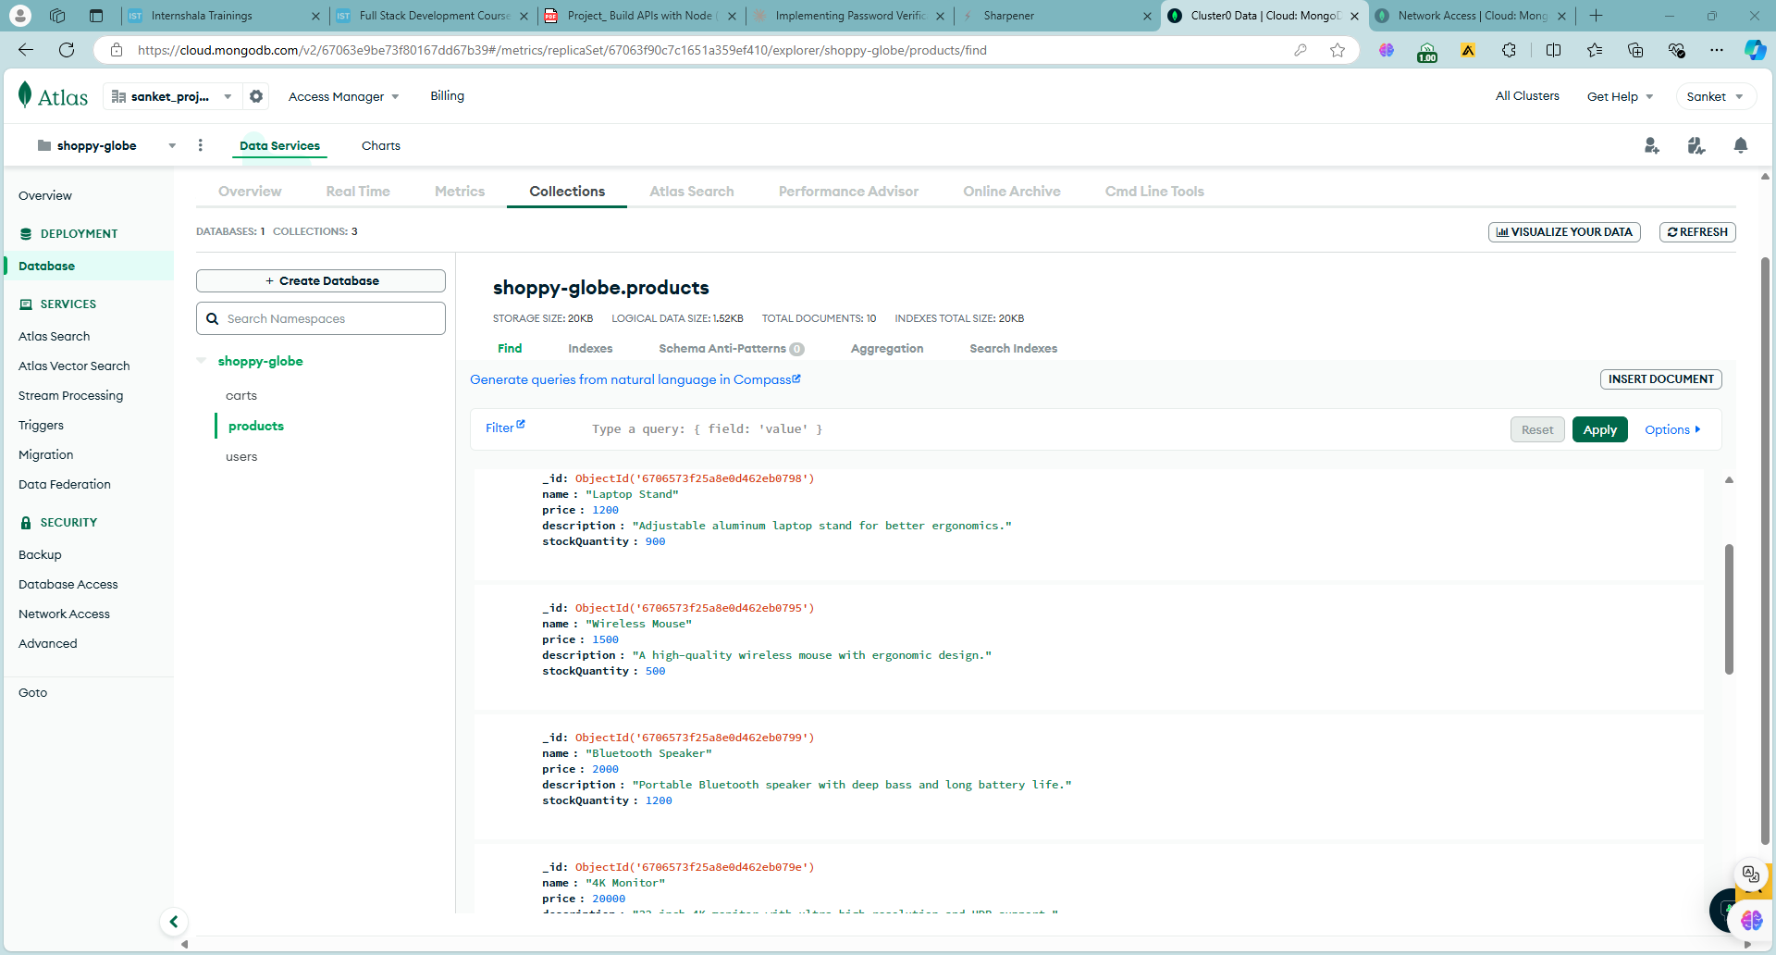

**2. Get Single Product**

* **Endpoint:** GET /api/v1/products/:id
* **Description:** Retrieves a single product by its ID.
* **Response:** Single product object.

POSTMAN SC-

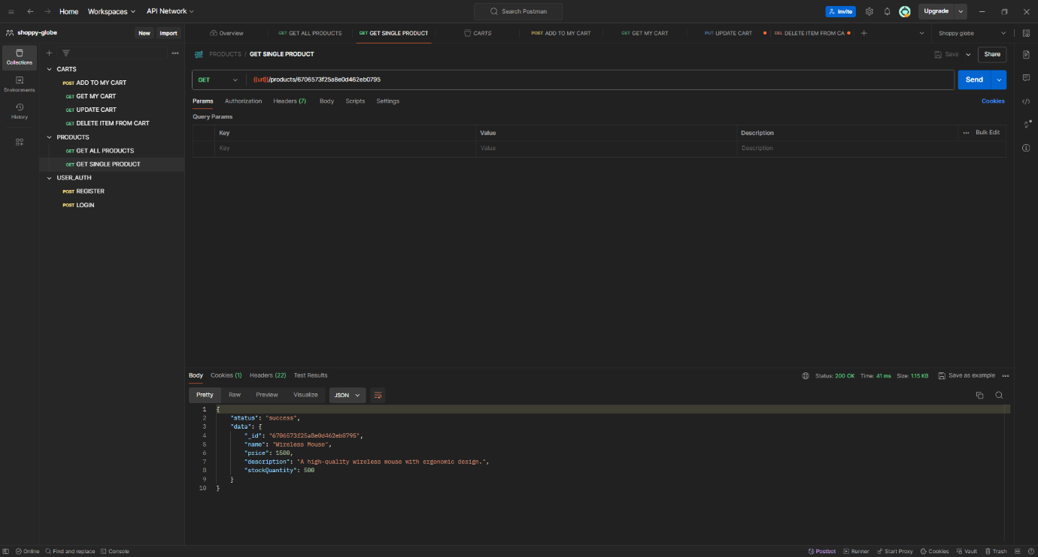

**3. Register User**

* **Endpoint:** POST /api/v1/auth/register
* **Description:** Registers a new user in the system.
* **Request Body:** User details (name, email, password).
* **Response:** User object with JWT token.

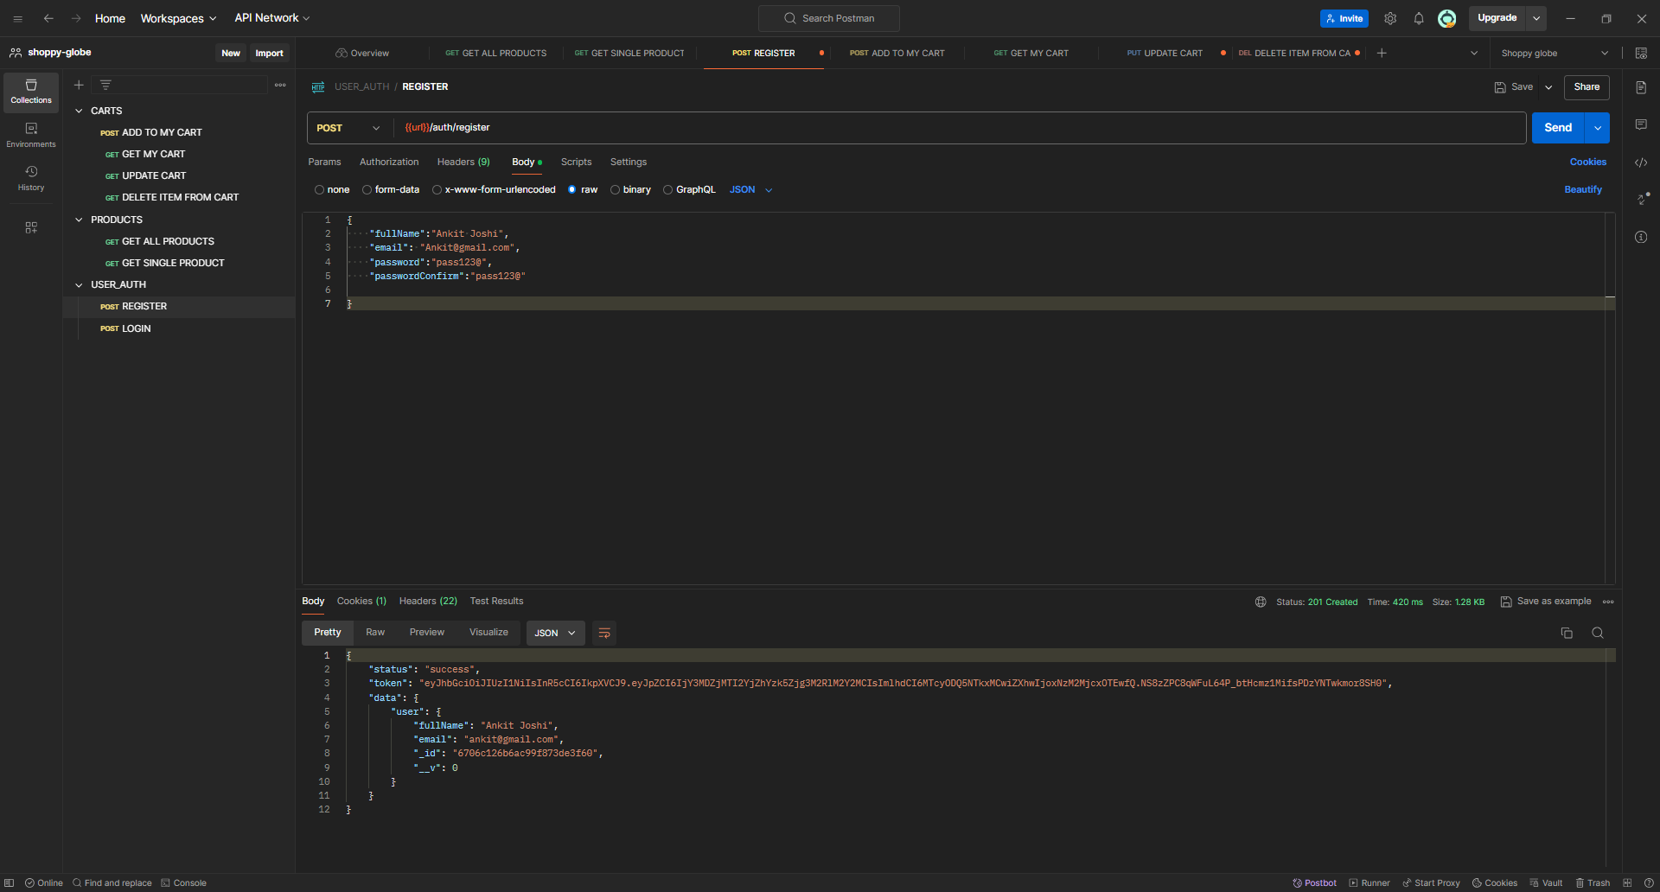

MONGO DB - 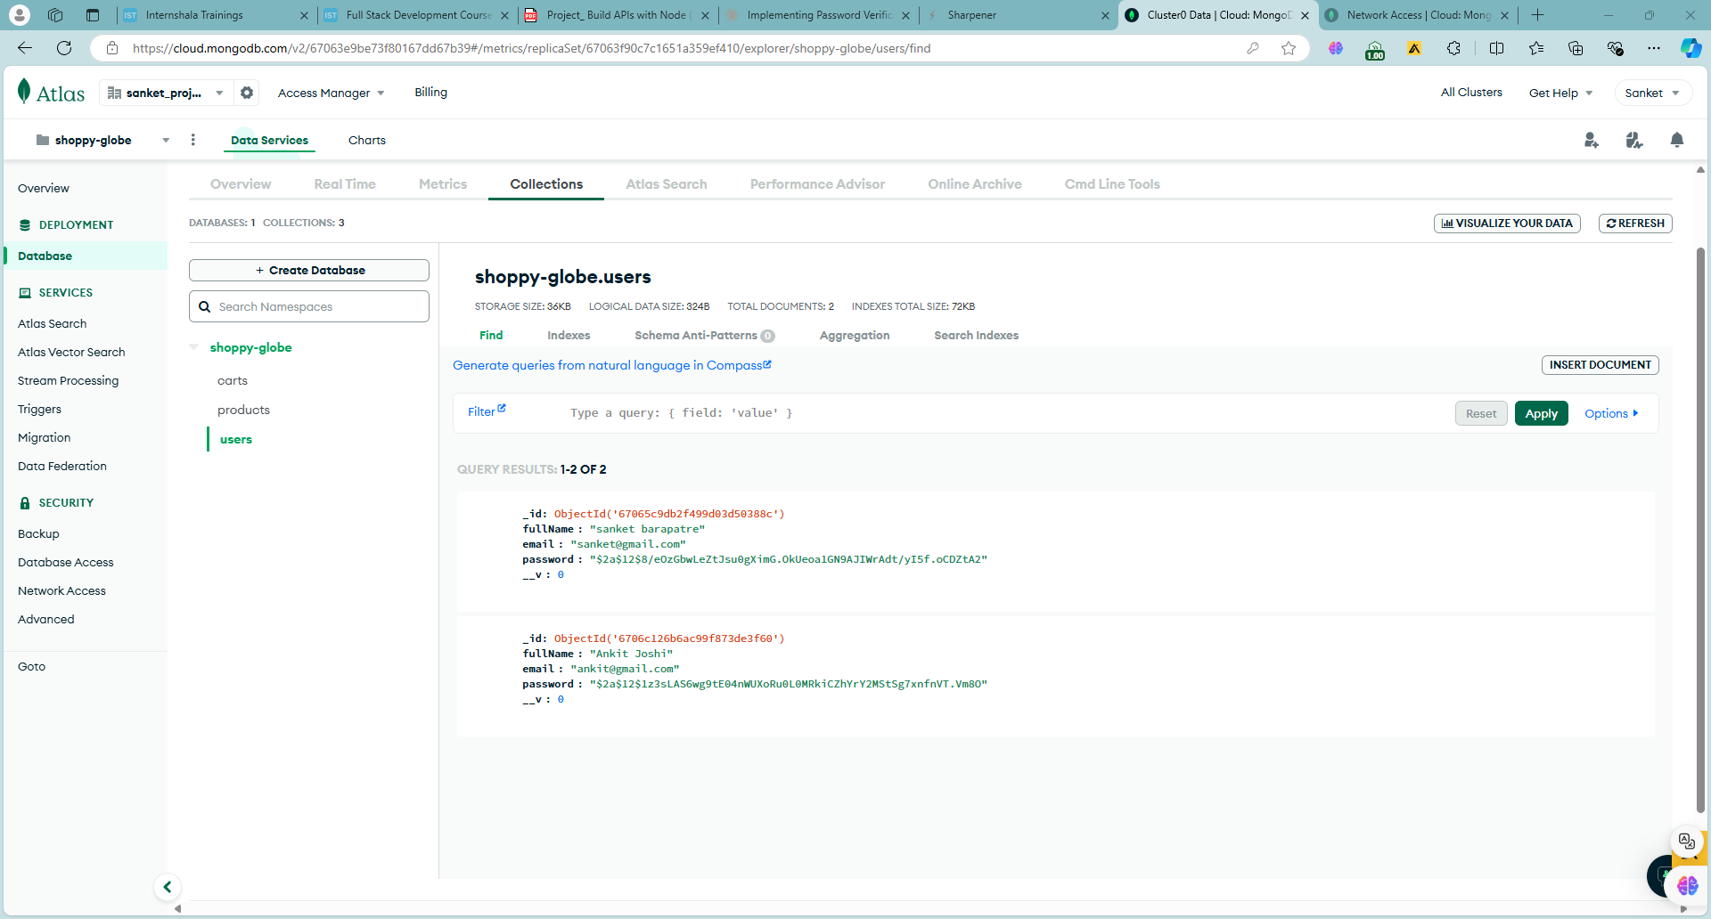

**4. Login User**

* **Endpoint:** POST /api/v1/auth/login
* **Description:** Authenticates a user and provides a JWT token.
* **Request Body:** User credentials (email, password).
* **Response:** User object with JWT token.

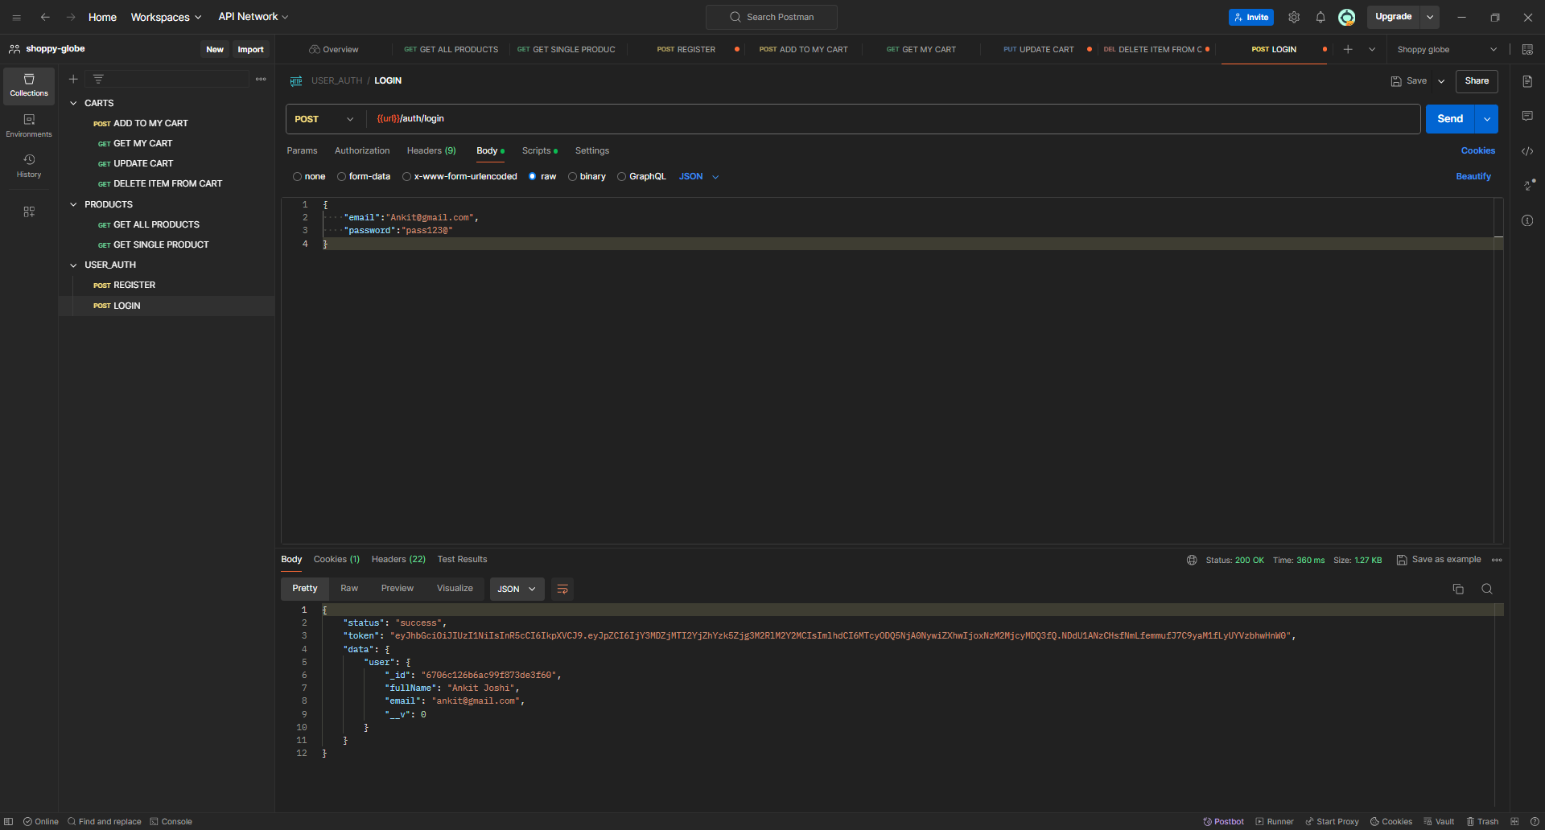

**\*\*\* All cart-related endpoints require user authentication.**

**5. Add Product to Cart**

* **Endpoint:** POST /api/v1/cart
* **Description:** Adds a product to the user's shopping cart.
* **Request Body:** Product ID and quantity.
* **Response:** Updated cart object.

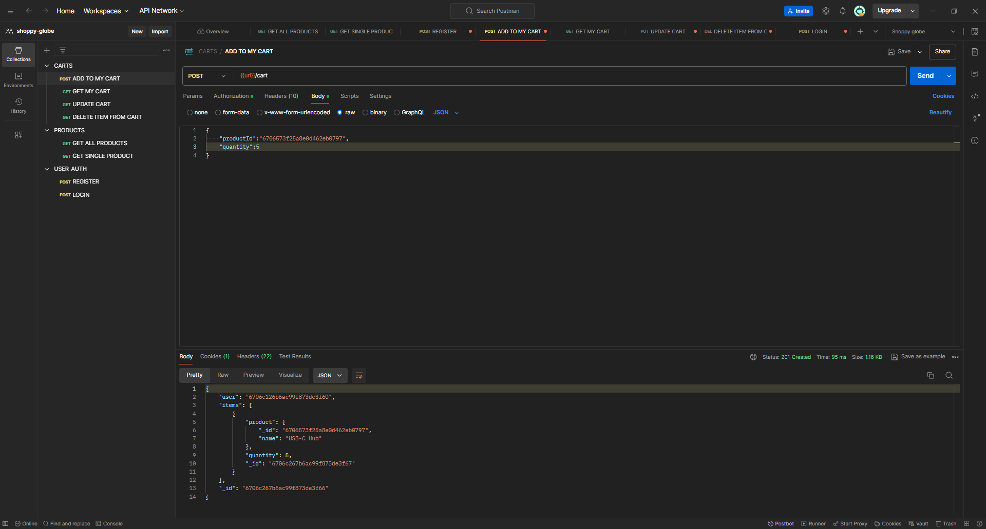

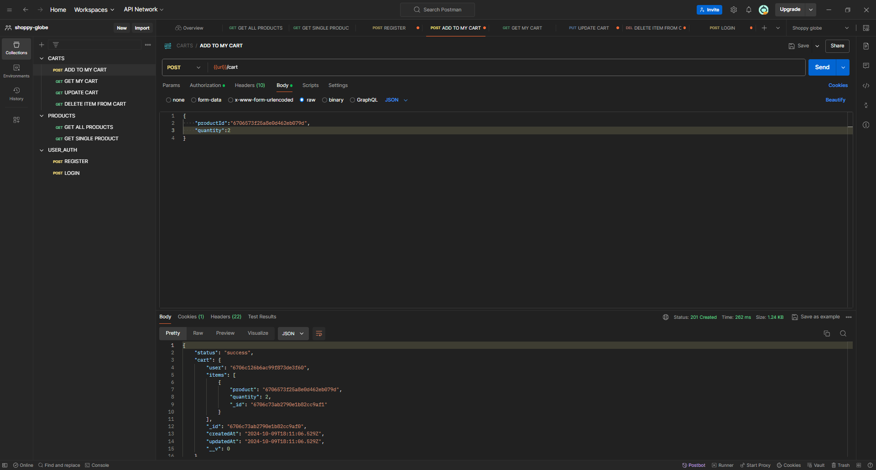

MongoDB Sc-

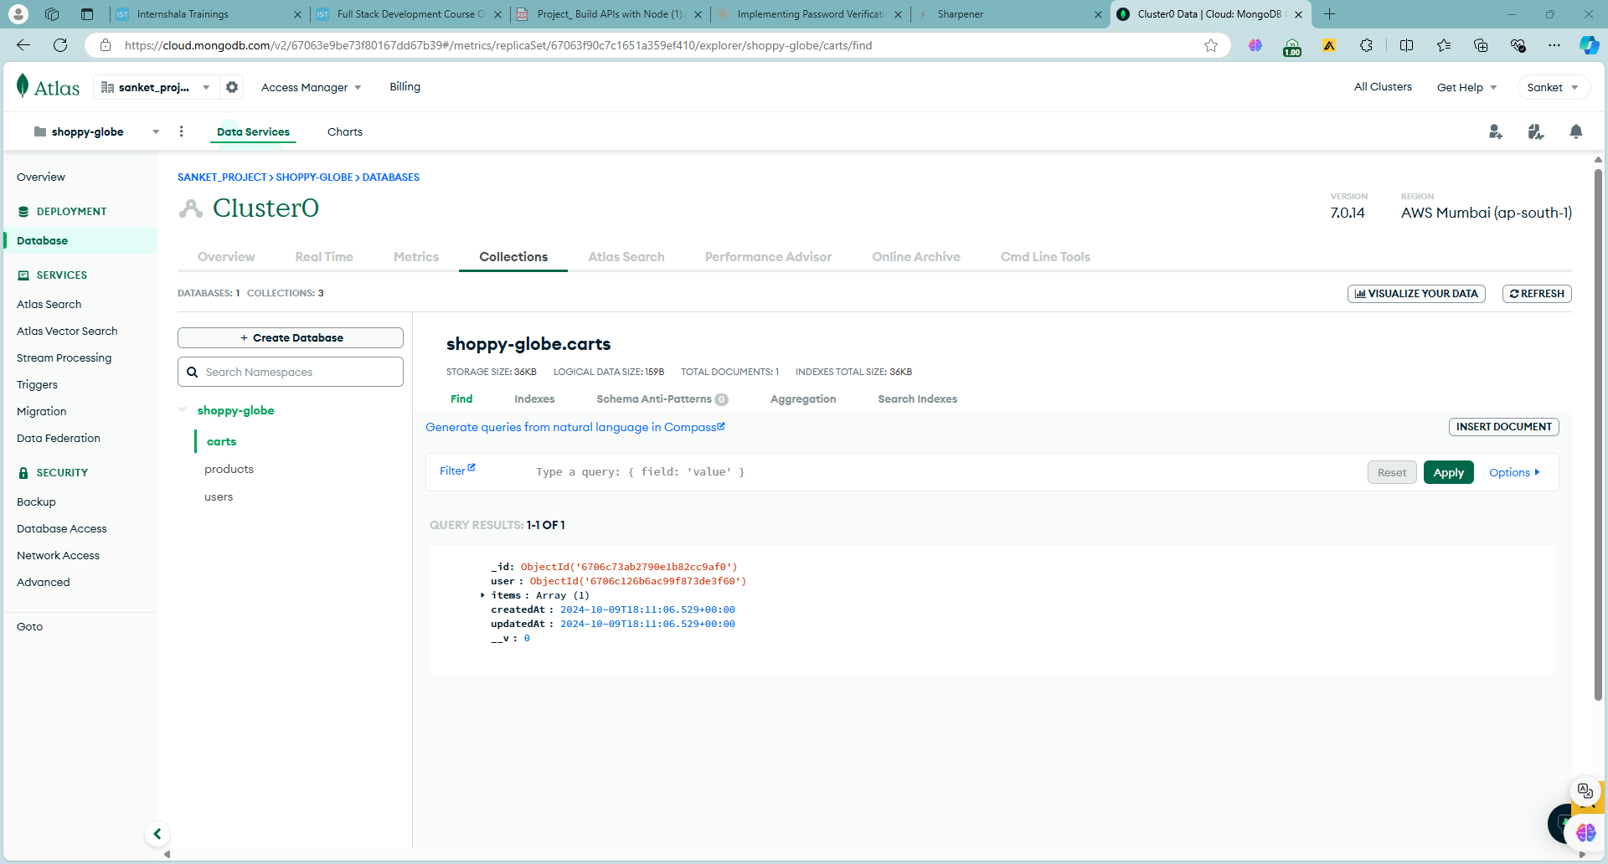

**6. Get User's Cart**

* **Endpoint:** GET /api/v1/cart
* **Description:** Retrieves the current user's shopping cart.
* **Response:** Cart object with items.

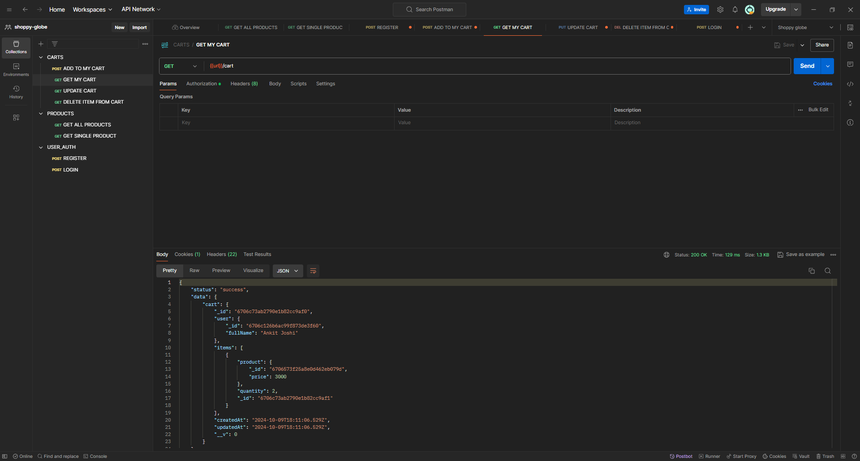

**7. Update Cart Item**

* **Endpoint:** PUT /api/v1/cart/:itemId
* **Description:** Updates the quantity of an item in the user's cart.
* **Request Body:** New quantity.
* **Response:** Updated cart object.

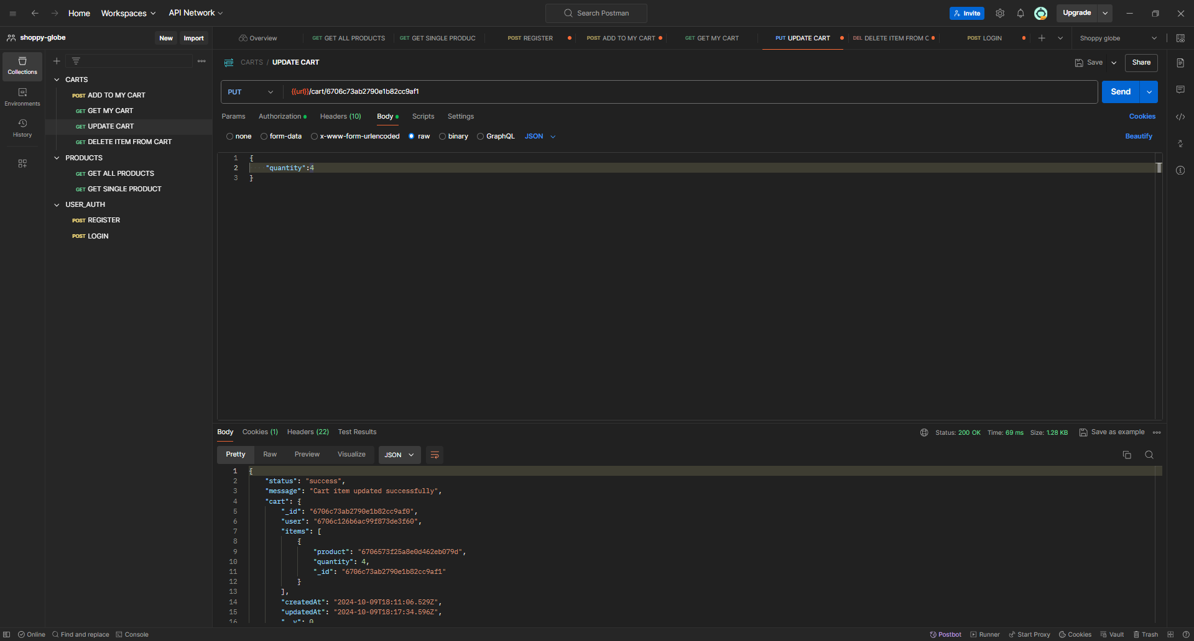

MongoDB-

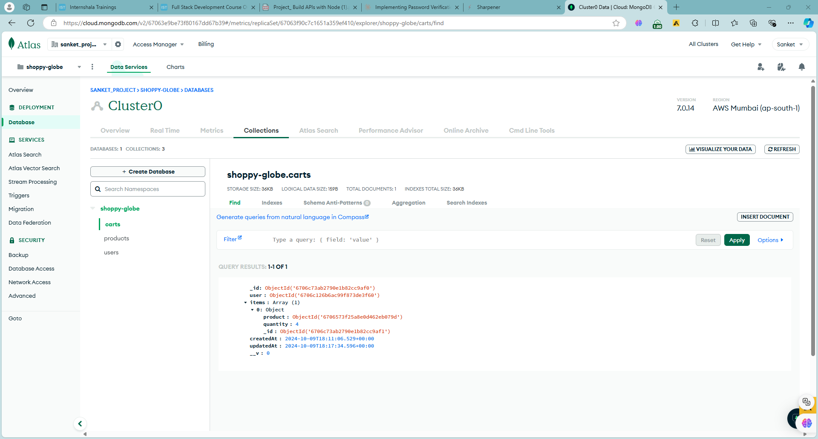

**8. Remove Item from Cart**

* **Endpoint:** DELETE /api/v1/cart/:itemId
* **Description:** Removes an item from the user's cart.
* **Response:** Updated cart object.

